**Daily Scrum or Standup Meeting**

Team name: __Team 10_______________________

Scrum Master: ___Zach Hawkes____________________

Date:_____3/21__________________________

|  |  |  |  |
| --- | --- | --- | --- |
| **Team Member** | **What did you do since the last scrum?** | **What do you plan to do before the next scrum?** | **What obstacles do you have?** |
| George Done | view movie | finish view movie and something from the next scrum | march madness |
| Zach Hawkes | Reviewed code and completed user login and create-user page | Configure admin site to edit users and movies | Lack of knowledge |
| Tanner Hooper | Created Movie model and init/nuke for dummy movies. | Create the movie list page to list all movies in DB. | Had to research a lot.Learning as we go... |
| Nick Jugganaikloo | Created search for movies page that takes data from an api and saves it to our database | Write unit tests for the search movie page, Improve styling. | I don’t know how to write unit tests |
|  |  |  |  |

# Burndown

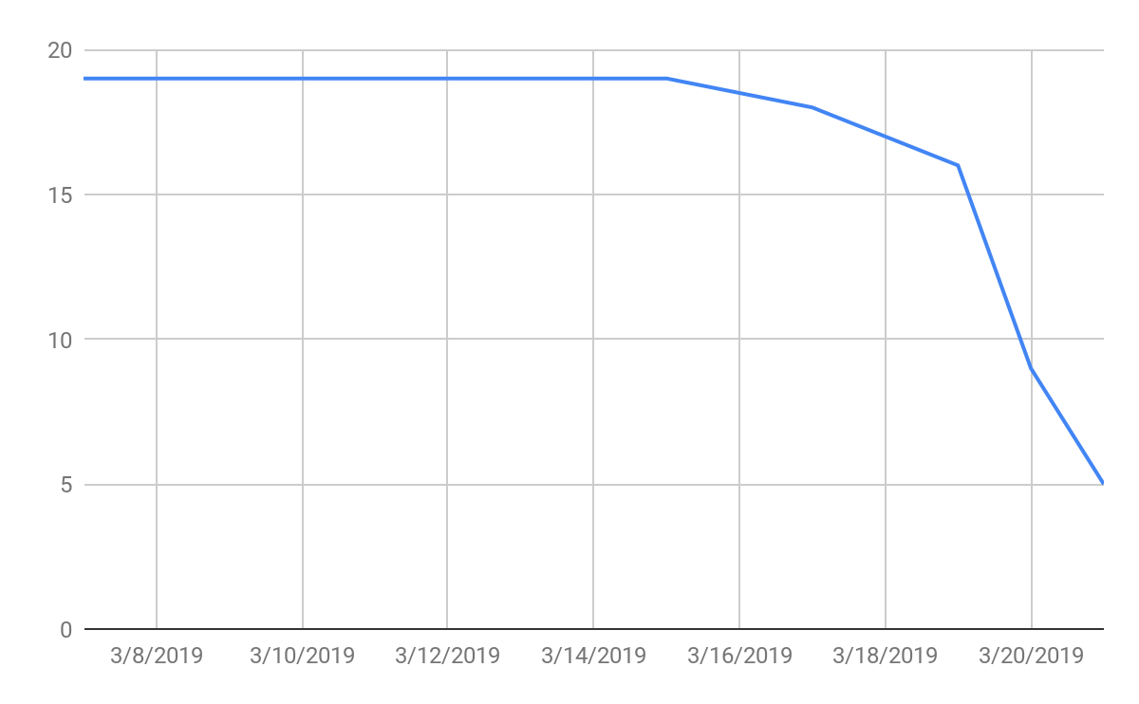

# Screenshot of you task board

